MACH4METAL

Metalworking machinery
Transito 21,
6909 DA BABBERICH
Netherlands
Tel. +31 (0)316 – 247123
Fax. +31 (0)316 - 247956
info@mach4metal.com
www.mach4metal.com

Account No: 66.52.13.883
IBAN : NL33 INGB 0665 2138 83
BIC : INGBNL2A

CME Moving column with 5 axis orthogonal milling head 1°

- Make : CME Spain
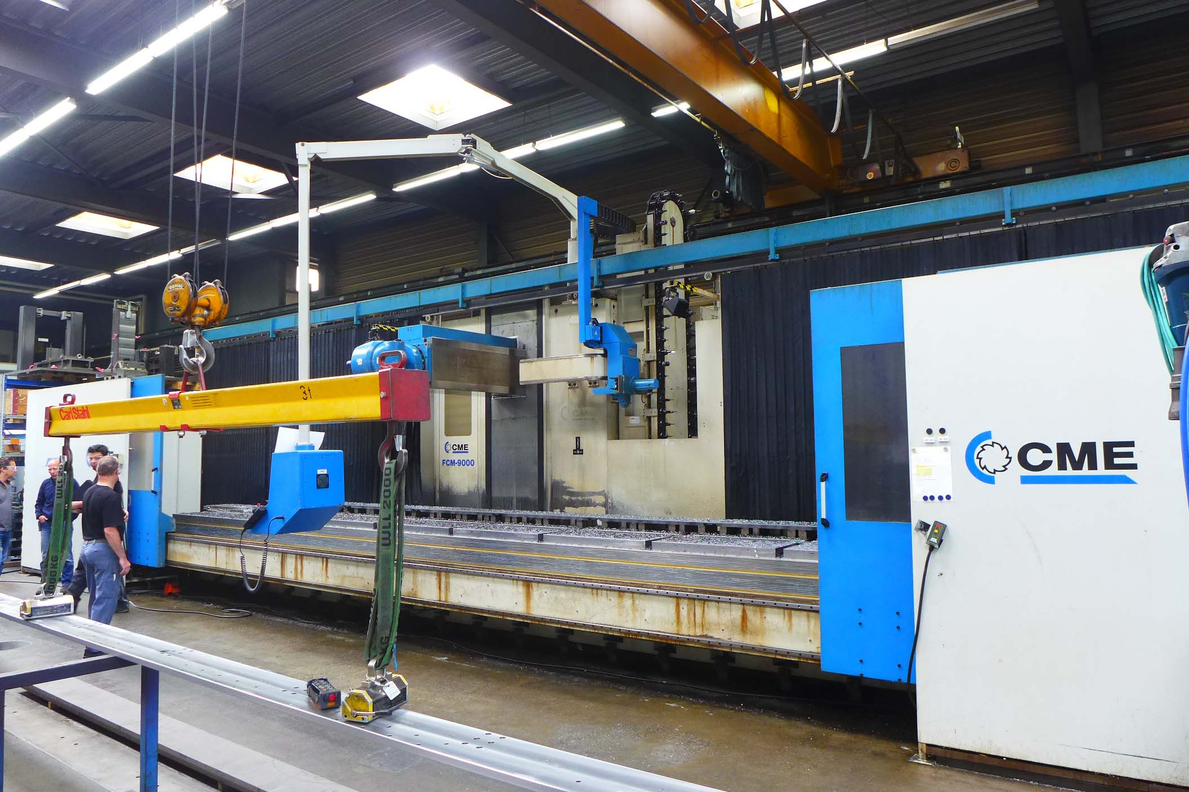
- Typ : FCM 9000
- Age : 2000
- No. : 901
- Control on hours : 11.500 (08.2017)

- Working area
- X Travel : 9.000
- Y Travel : 1.500
- Z Travel : 1.500
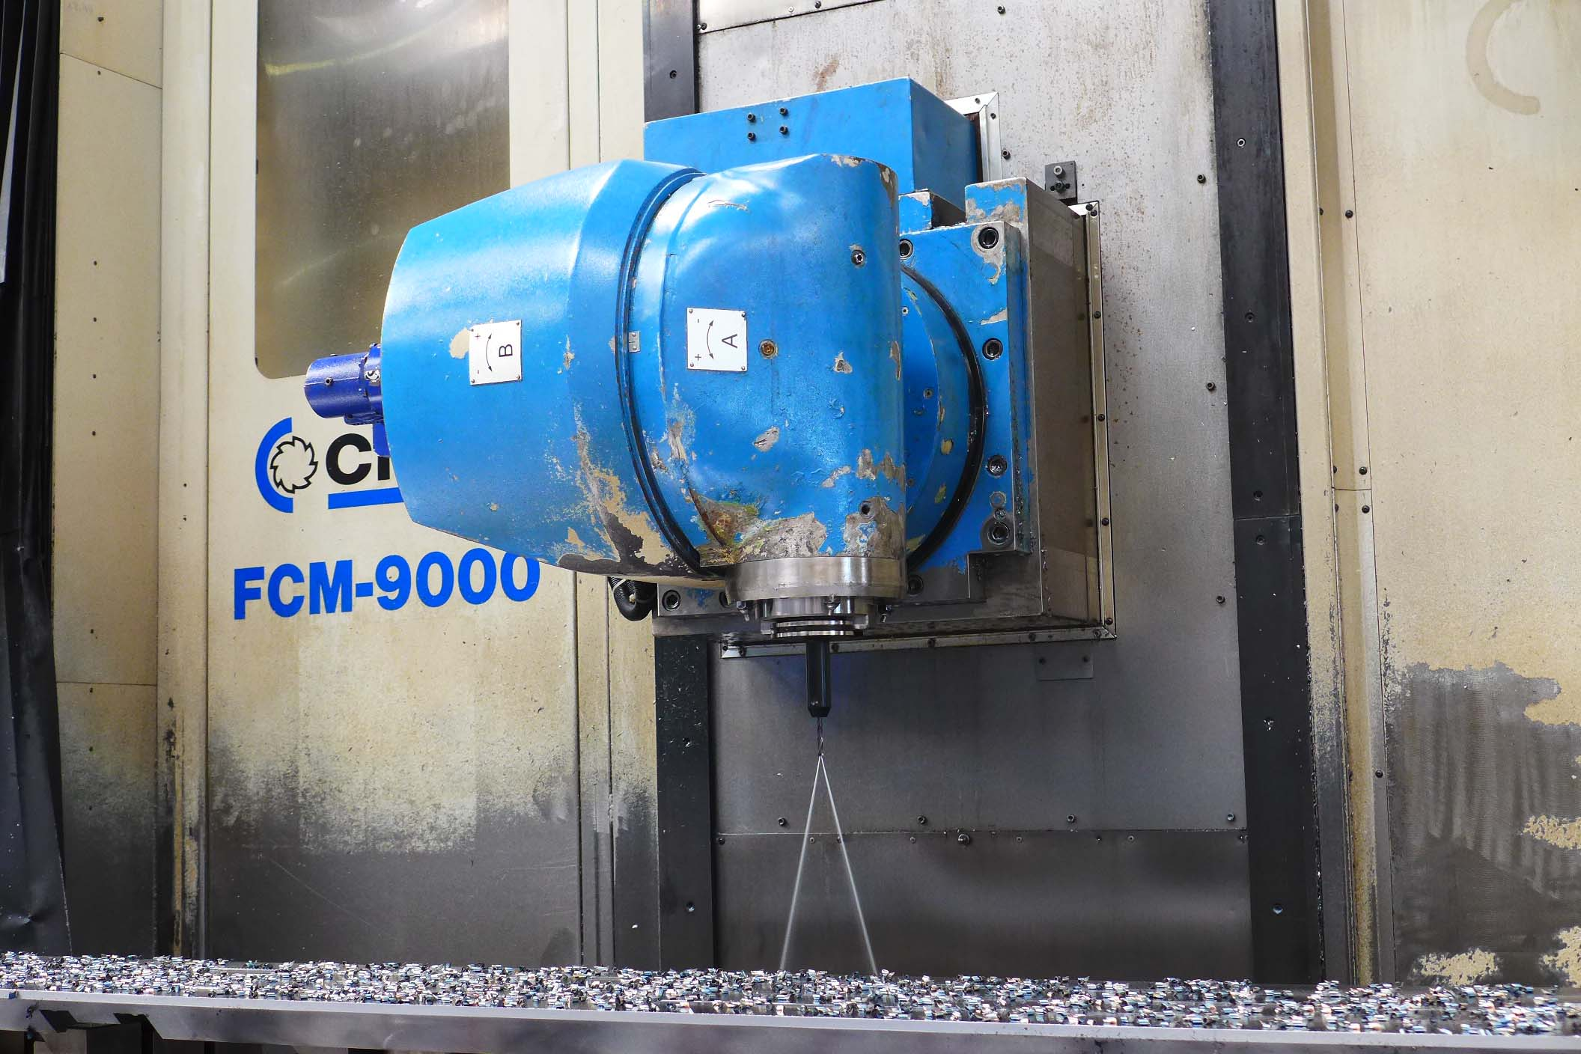
- Table length : 9.500
- Table width : 1.200
- Table load each M : 5.000

- Spindle : Sk50
- Speeds : 60 – 3.000 Rpm
- Milling head power : 30 kW

- Orthogonal CNC Milling head
- A axis : 1 Gr
- B axis : 1 Gr
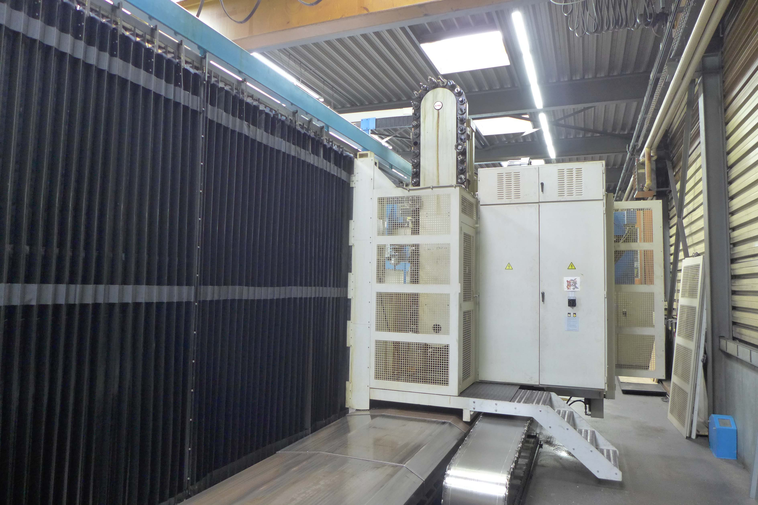
- Head / Spindle rebuild in 06.2017

Please Note: The above information has been obtained to the best of our ability and belief from, and from the manufacturers where possible. It is given in good faith, but its accuracy can not be guaranteed. Accordingly, it will not form a representation or constitute contractual terms. We advise you to check any vital details!

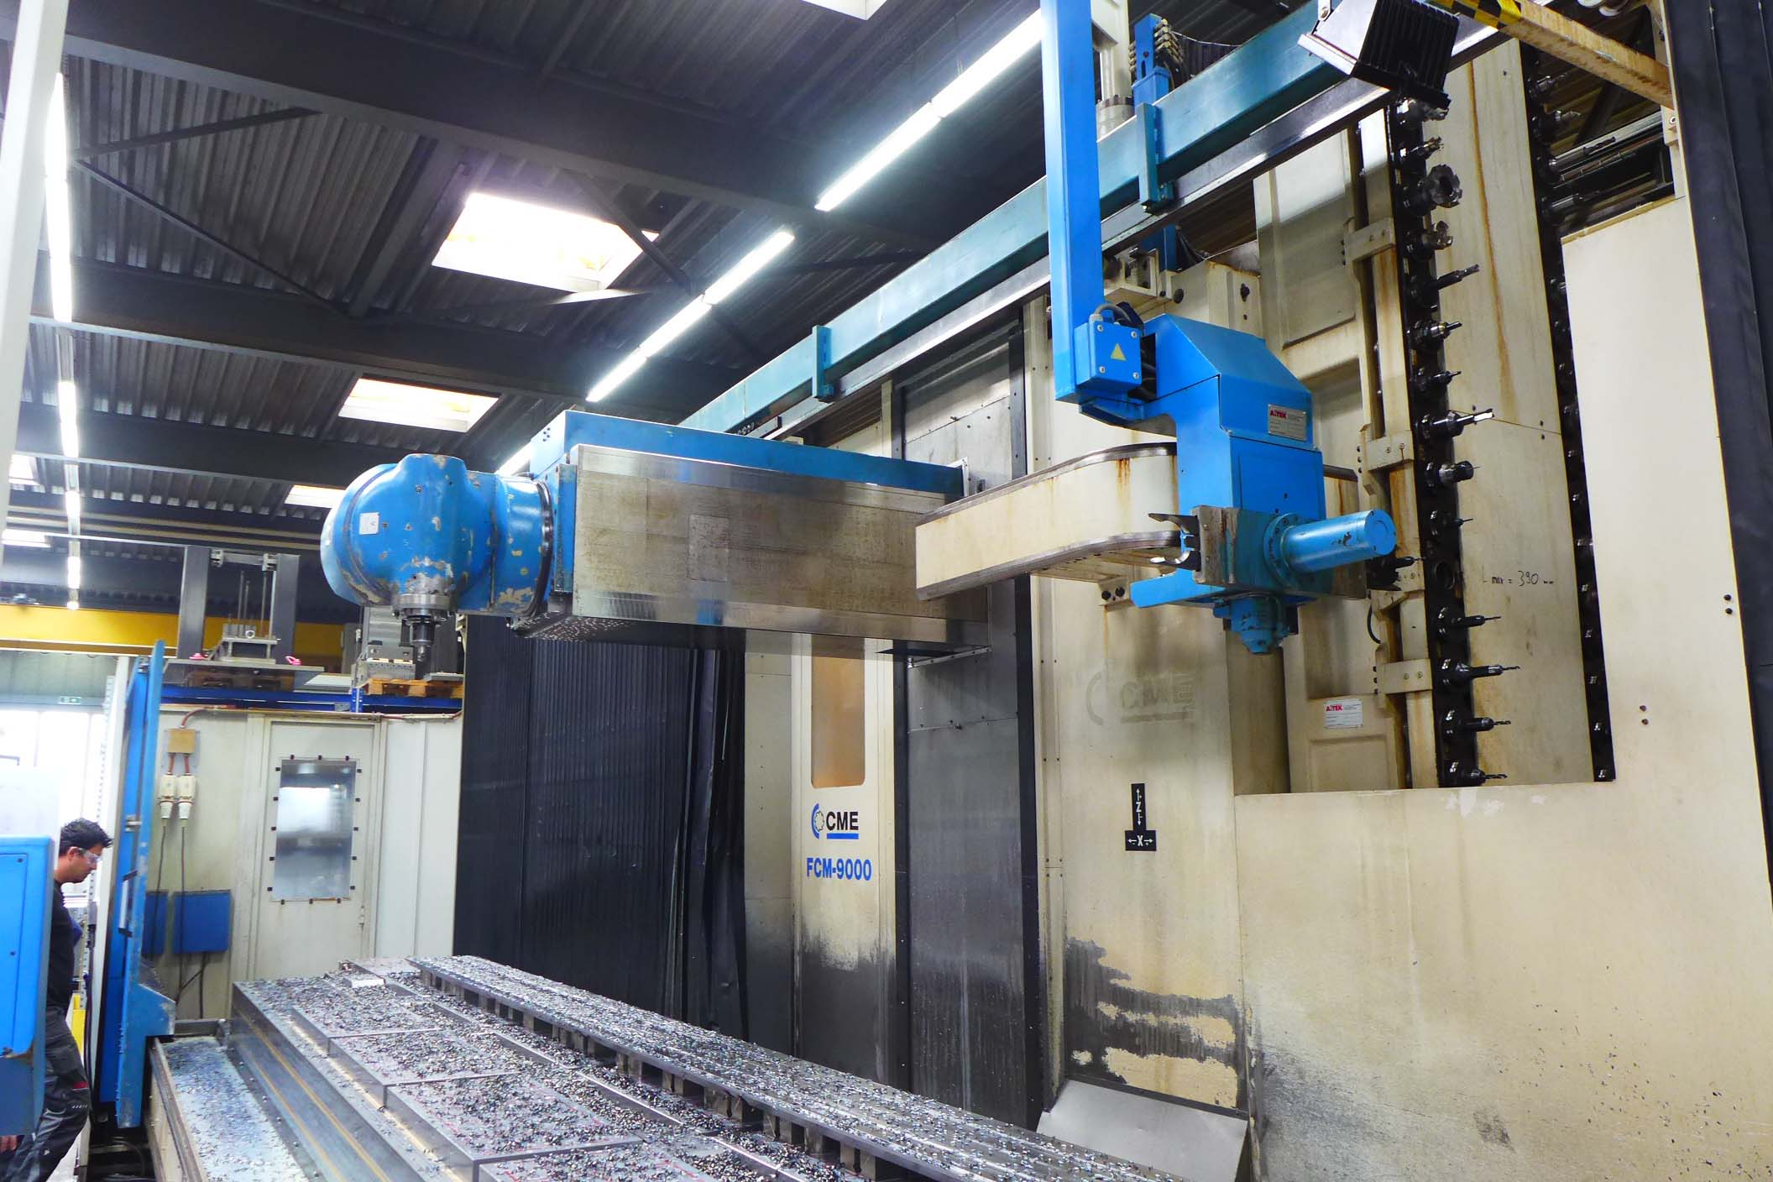

- Feed rate X : 0,01 – 5.000 rpm
- Feed rate Y :
- Feed rate Z :
- Feed rate A / B
- Rapid traverse : 0,01 – 15.000 rpm

- CNC Control HeidenHain TNC 430
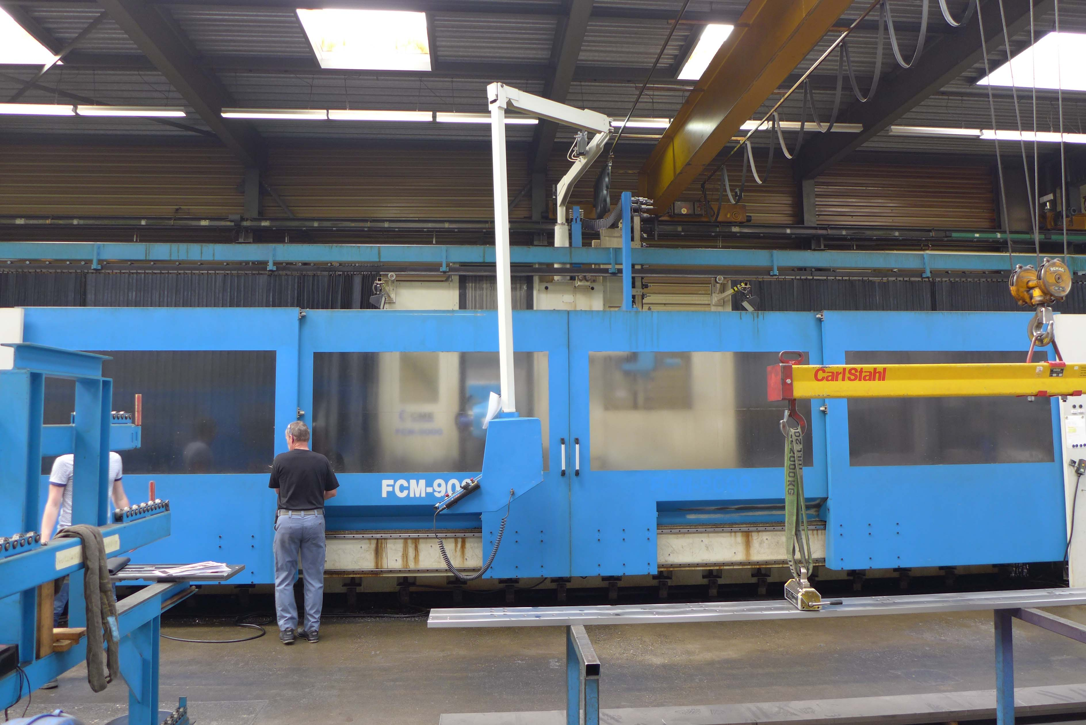
- Controlled axis over CNC X/Y/Z
- Controlled axis over CNC A/B

- ATC chain 60 positions Aitek
- High pressure coolant 20 Bar
- Chip conveyor
- Covered machine with 4 big doors
- Central lubrication
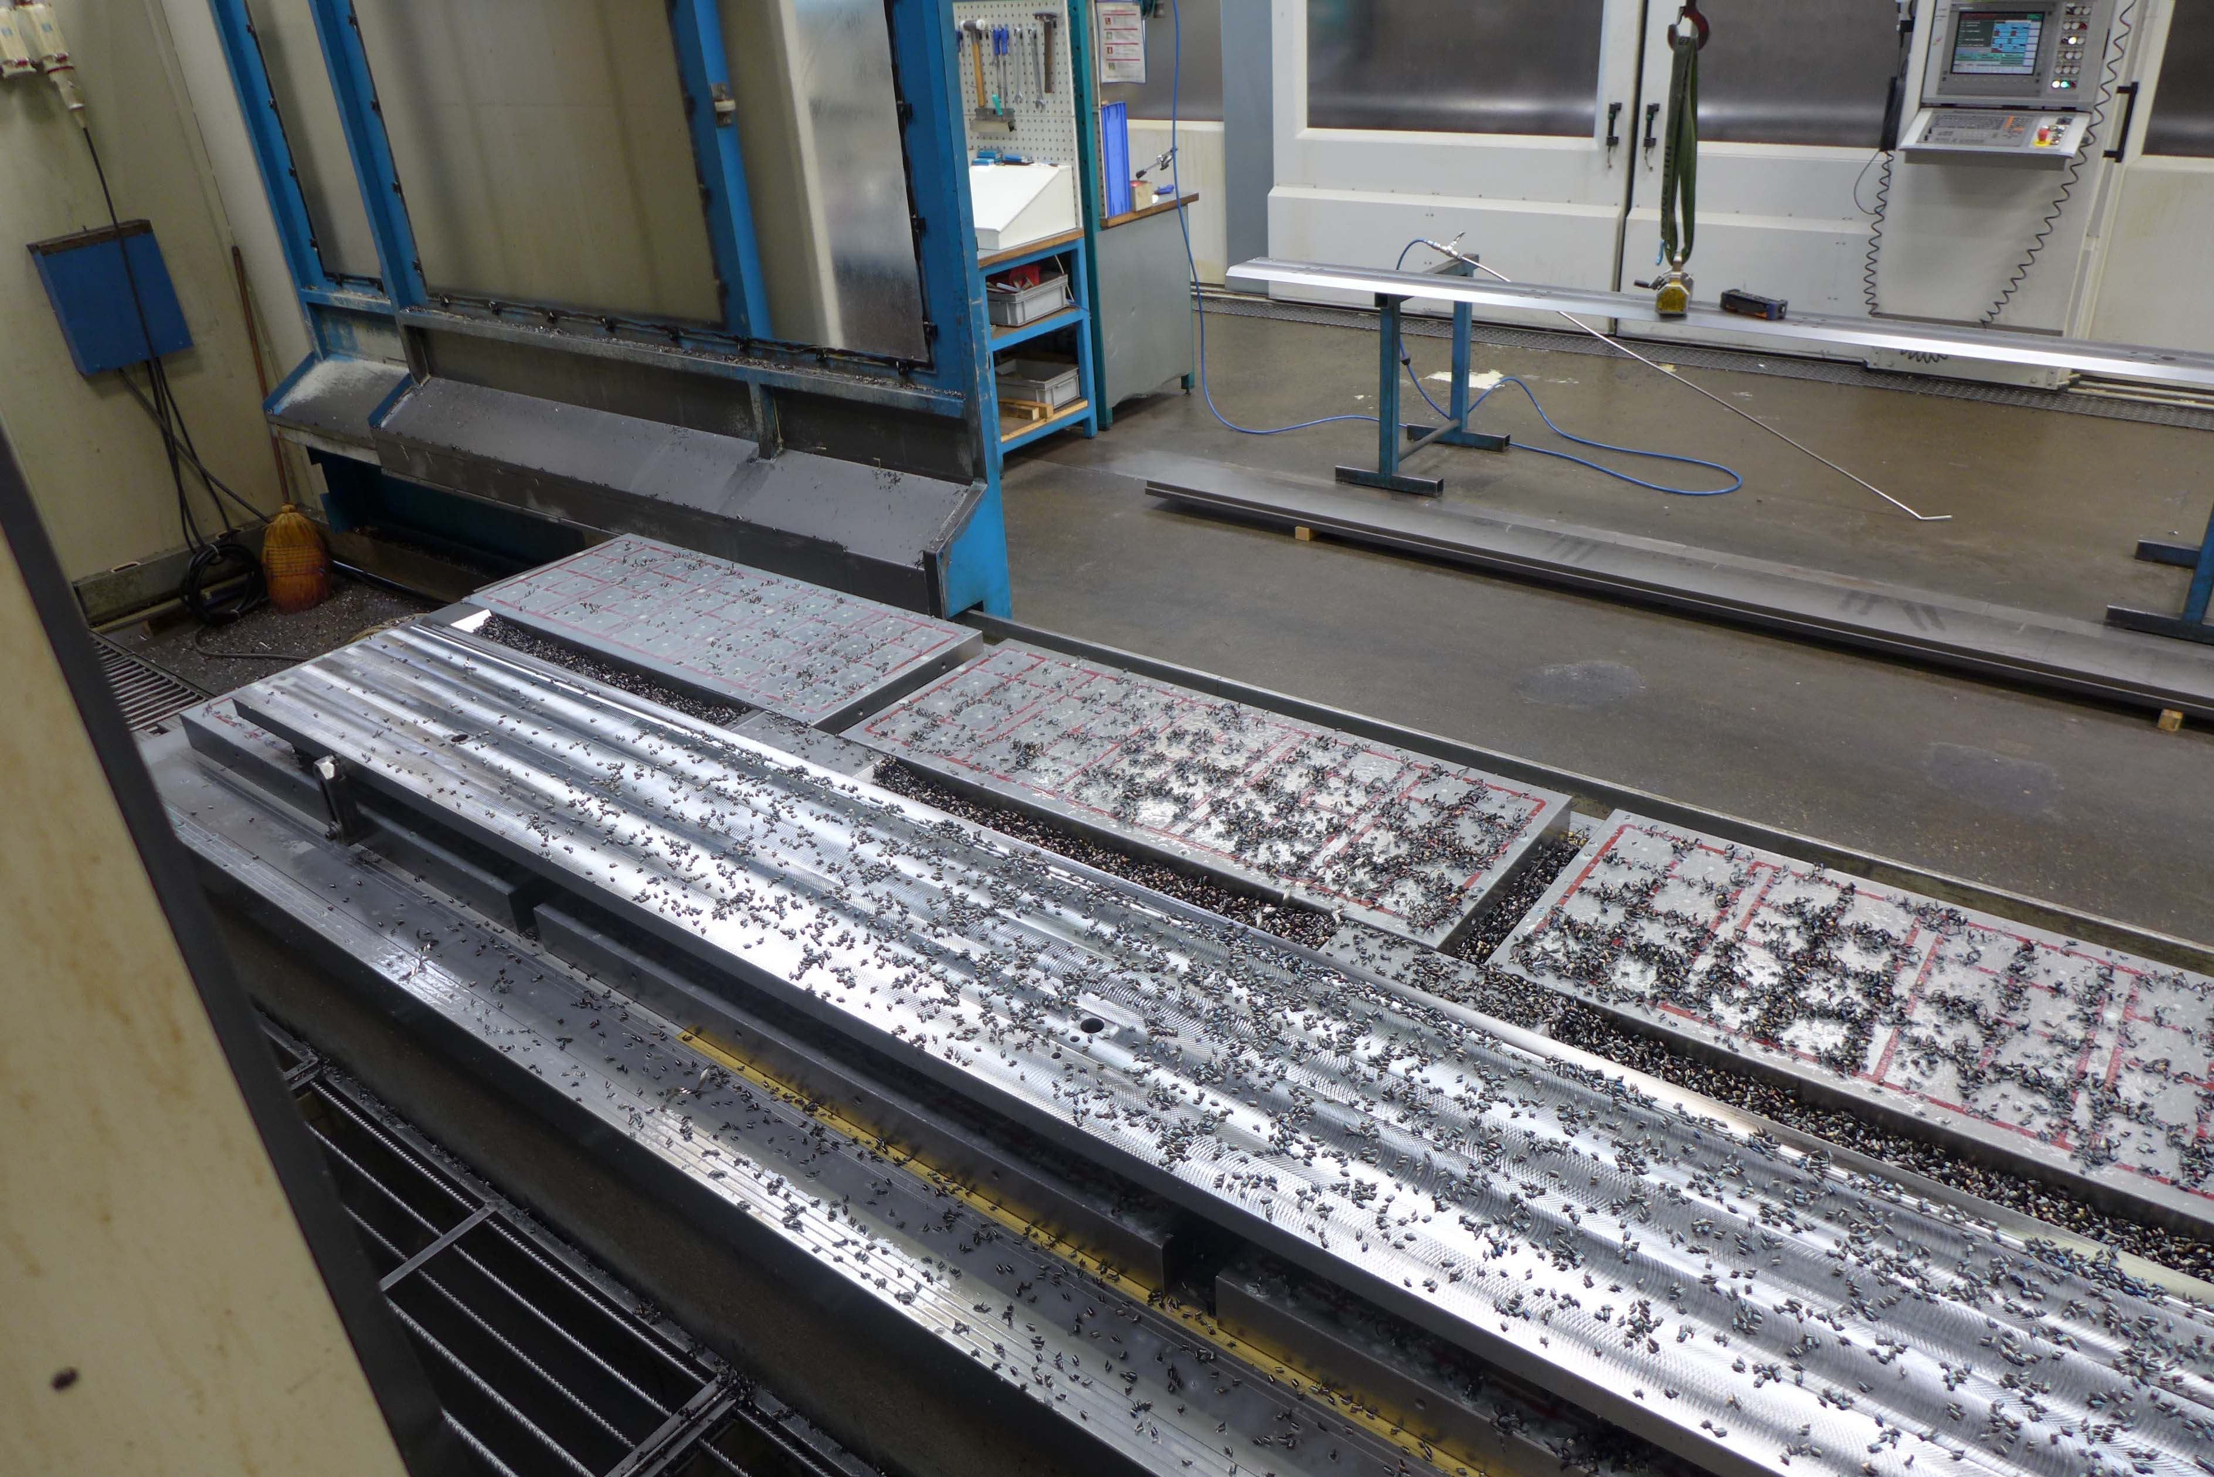

- Dimensions overall

- Length : 16.000
- Width : 6.000
- Height : 6.000
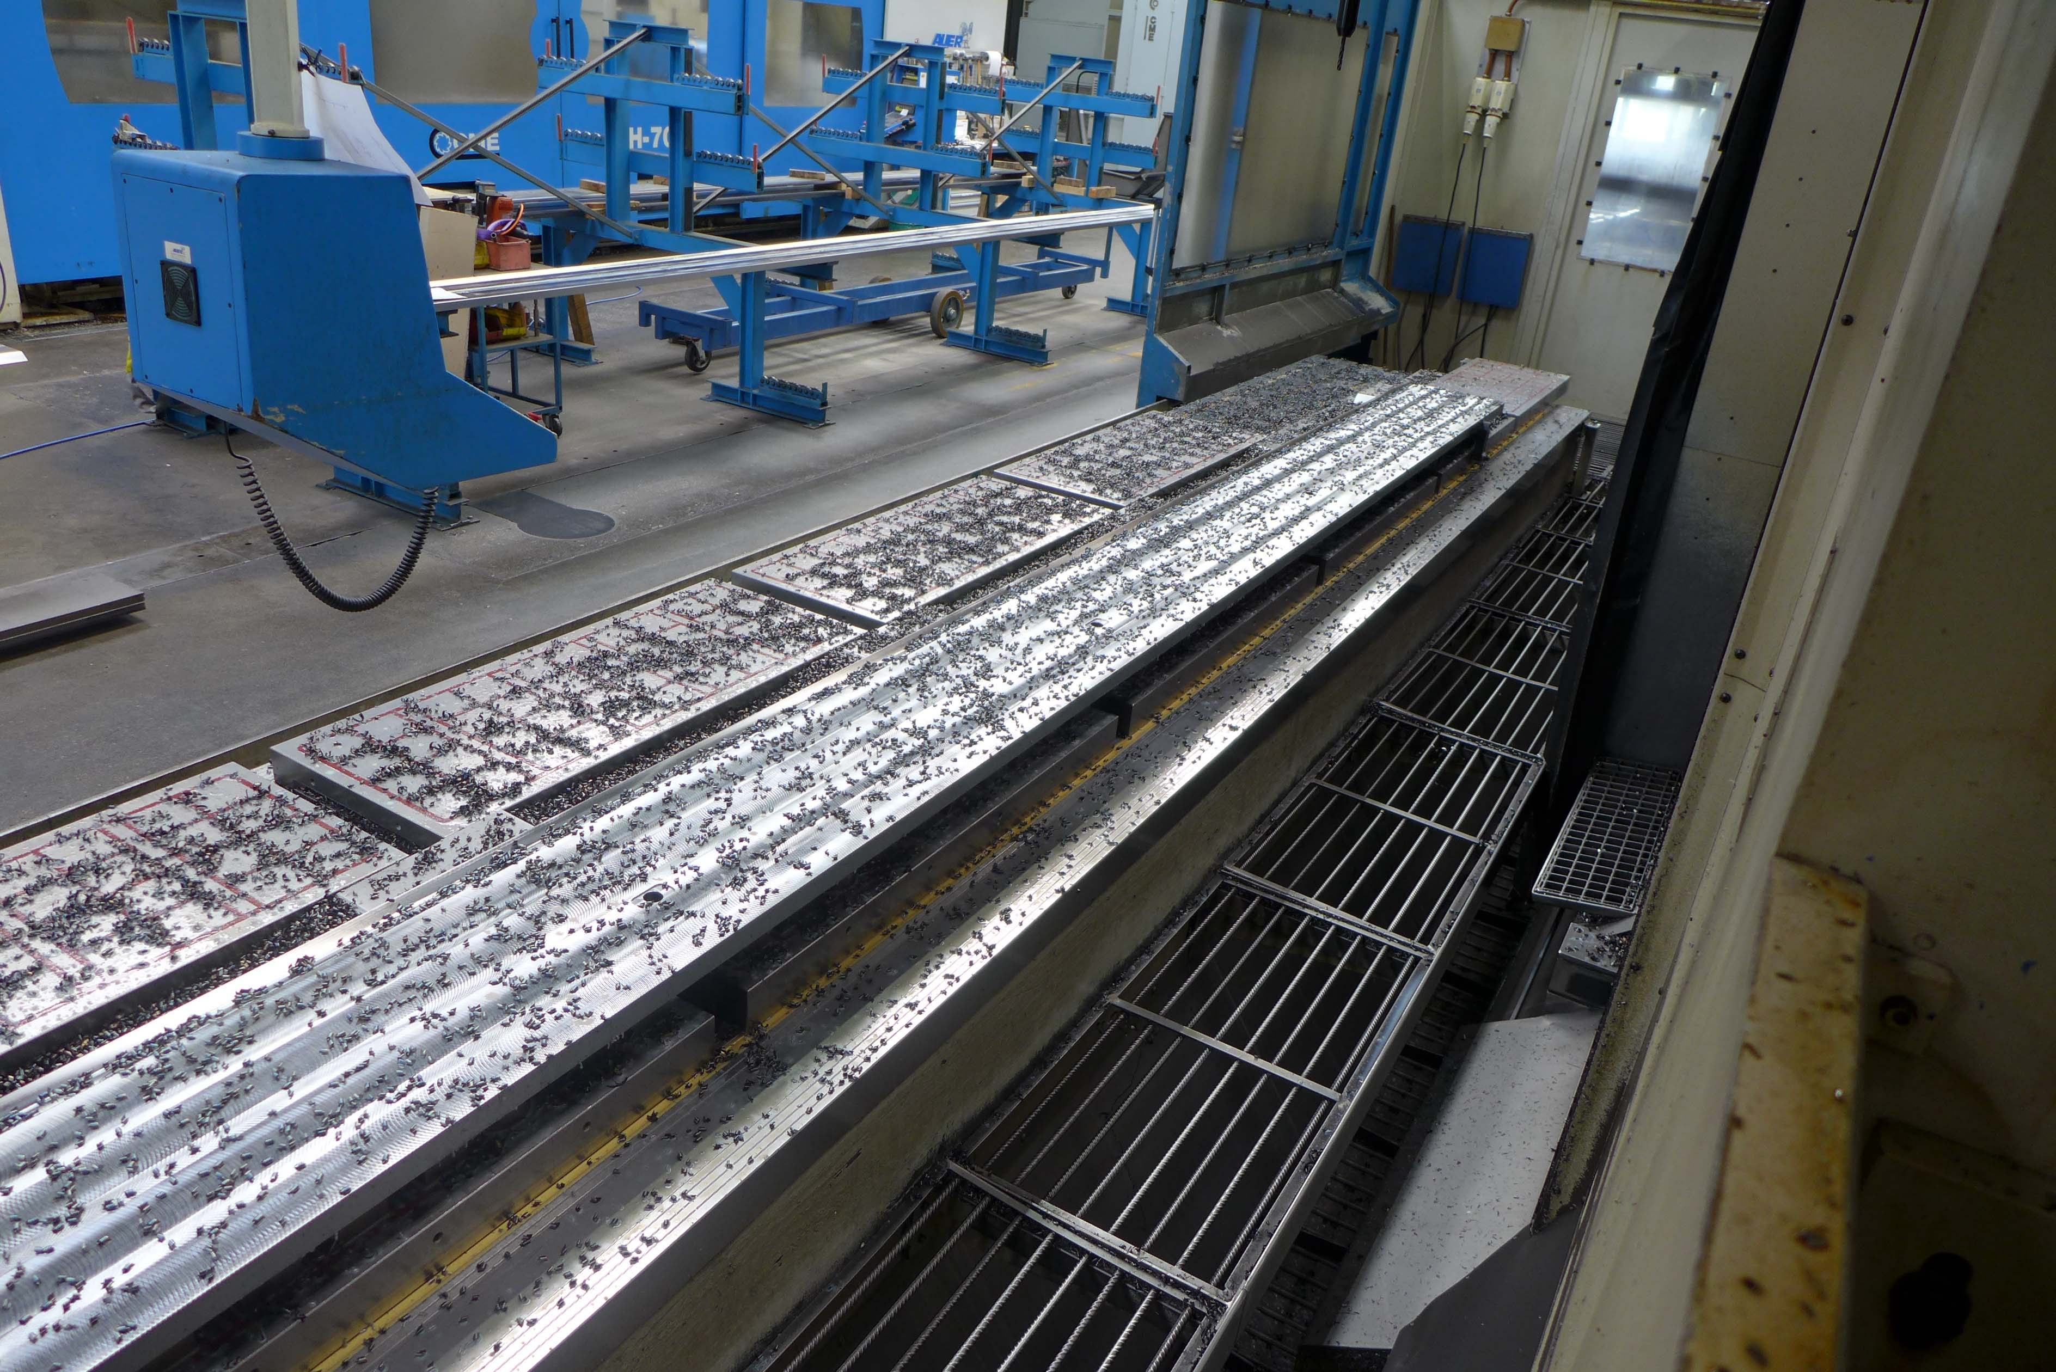
- Weight : 68.000
- Installed power : ..

- Machine from 1e owner 1 shift
machine with 11500 Hours
- Excellent maintained machine
- Incl. all books / drawings / manuals

Please Note: The above information has been obtained to the best of our ability and belief from, and from the manufacturers where possible. It is given in good faith, but its accuracy can not be guaranteed. Accordingly, it will not form a representation or constitute contractual terms. We advise you to check any vital details!

